CAPSTONE PROJECT

**- Create monthly report of the students of management**

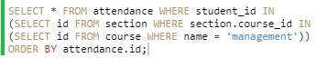

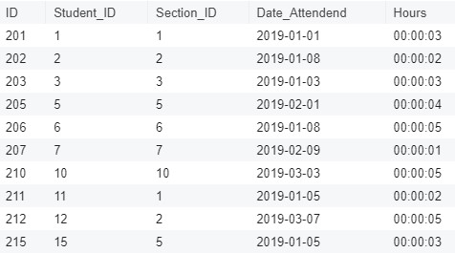

Here, I have first selected the ID of ‘management’ course, then the ID of section where the ‘course ID’ matches the selected ‘management ID’. Then, selecting the record from attendance table where ‘student id’ matches the selected ‘course ID’ i.e. ‘management.

**- Determine the list of students who have enrolled for multiple courses thus finding out most popular one**

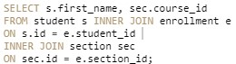

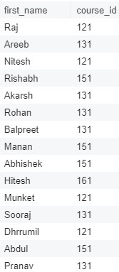

Joining the student and enrolment table on ‘student id’, later joining the resulting table with section table on ‘section id’ gives the list of students who have enrolled for the course with course name.

**- prepare a schedule for every instructor to determine the courses they are supposed to conduct**

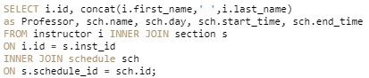

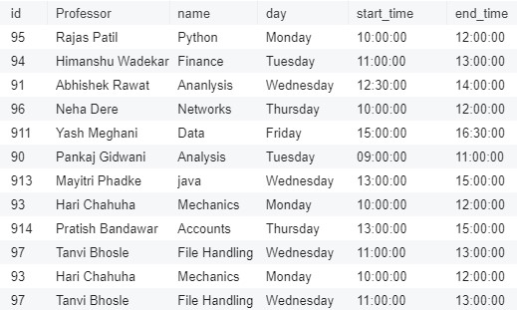

Joining the instructor table with section table on ‘instructor id’ and joining the resulting table with schedule table on ‘schedule id’ gives the schedule for every instructor.

**- Make a marksheet of every student for every course**

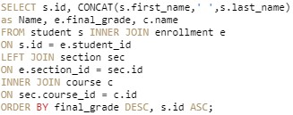

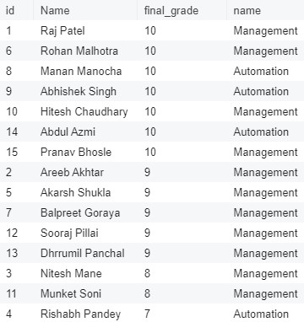

**Joining the student table with enrolment table on ‘student id’ , left joining the resulting table with section table on ‘section id’ and finally inner joining the resulting table with course table on ‘course id’.**

**- Determine how many instructors are present for every department**

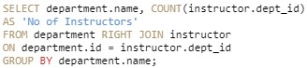

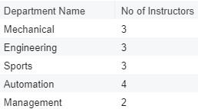

Right Joining the department table with instructor table on ‘department id’ and selecting department name and count of instructors with corresponding department id. Finally grouping it bt department name gives us the resulting table.

**-Find courses that are offered based on its types**



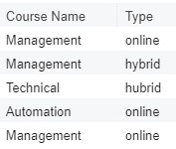

Selecting name and type of course from the course table.

**-classrooms occupied during particular time interval in the schedule**



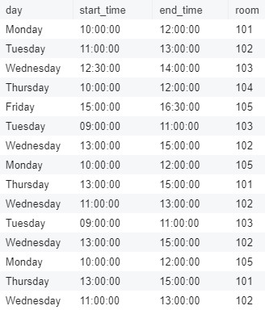

Right joining schedule with section on ‘schedule id’ gives the resulting table.

**-find students with absences (3 hrs)**



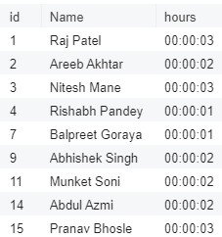

Joining student table with attendance table on ‘student id’ with condition (hours less than or equal to 3) gives the resulting table,

**-Print course names for sections with unassigned instructors**



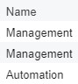

Joining course with section on ‘course id’ and selecting the data where ‘instructor id’ is NULL gives the resulting table.

**-Find courses with no more than 1 section**

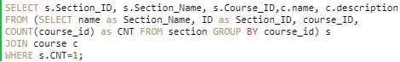

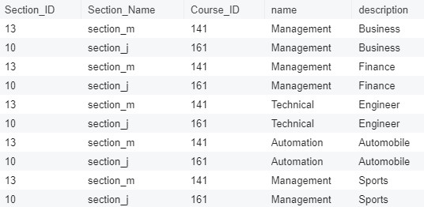

Firstly, selecting data from section table and grouping by ‘course id’ and giving it an alias. Secondly, joining the resulting table with course table and selecting data from that with condition (count of course id =1)

**TABLES**

-Student Table

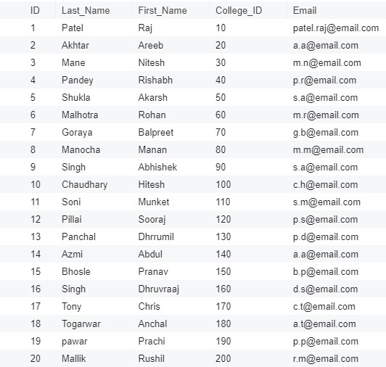

-Course Table

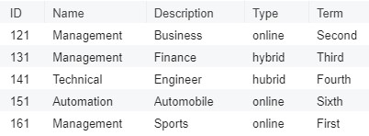

-Instructor Table

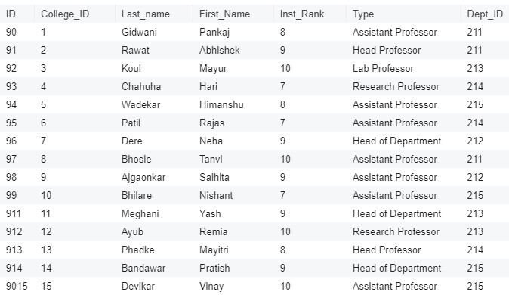

-Attendance Table

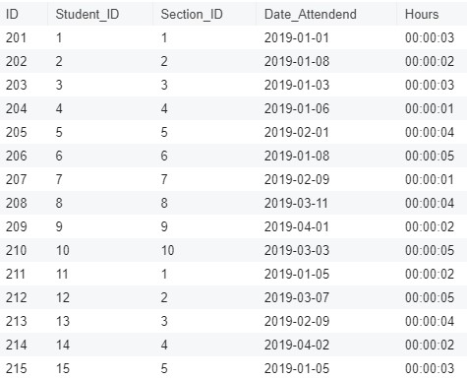

-Enrolment Table

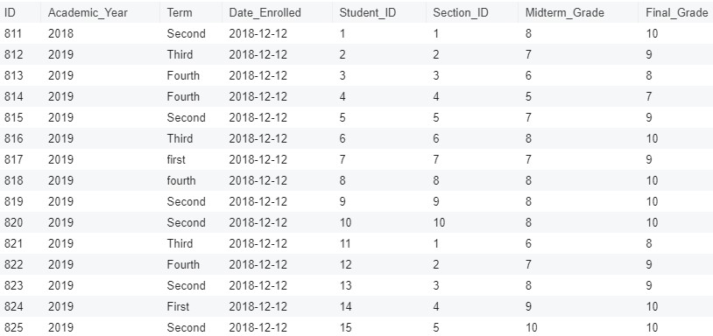

-Section Table

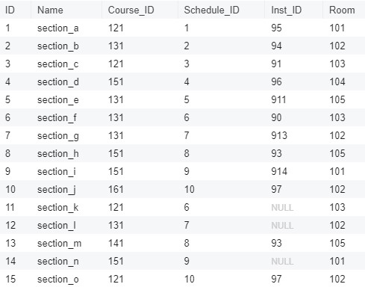

-Schedule Table

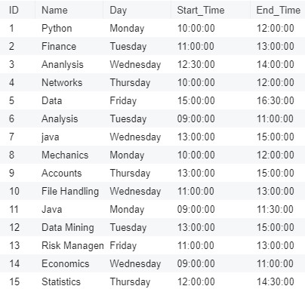

-Department Table

